Oracle EBS Item Verification
Validated item attributes and Oracle EBS evidence

F-5412-991
ADHESIVES
Main - GRI Glen Rock Inventory
Item Number = F-5412-991 PASS
Primary UOM = POUND PASS
User Item Type = ARCARE PASS
Long Description = Blank PASS
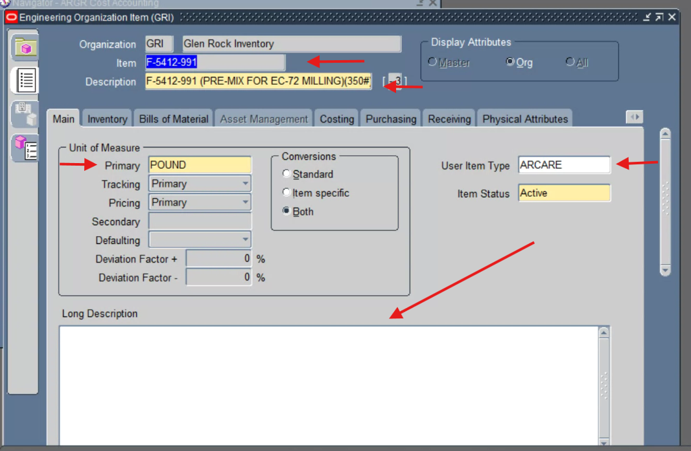
Oracle EBS evidence - Main - GRI Glen Rock Inventory

F-5412-991
ADHESIVES
Main - MAS Master Inventory
Item Number = F-5412-991 PASS
Primary UOM = POUND PASS
User Item Type = ARCARE PASS
Long Description = Blank PASS
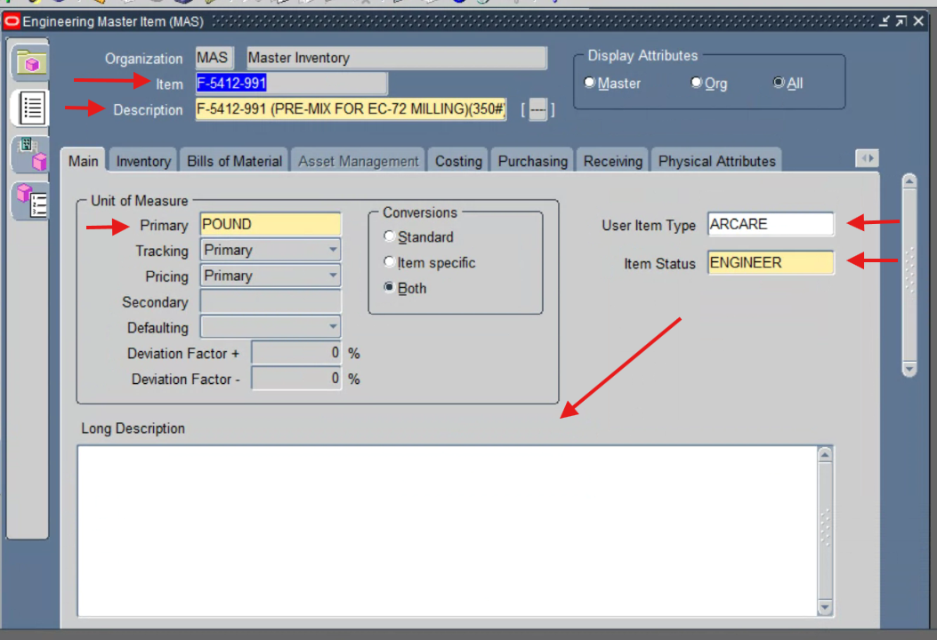
Oracle EBS evidence - Main - MAS Master Inventory

F-5412-991
ADHESIVES
Item Descriptive Flexfield - GRI
PDR Number = 26-16 PASS
Construction = 31.6 % SOLIDS; 7.5 LBS/GAL PASS
Initiator = Christina Wilson PASS
Average Container Size = 350 PASS
HIMS = 230 PASS
Lead Time Days = 20 PASS
Percent Solids = 31.6 PASS
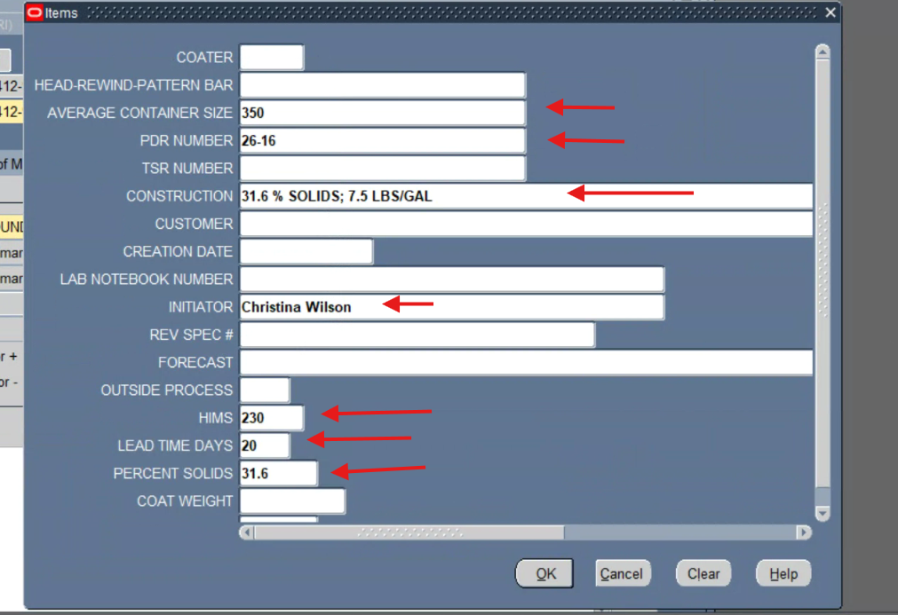
Oracle EBS evidence - Item Descriptive Flexfield - GRI

F-5412-991
ADHESIVES
Physical Attributes - GRI
Unit Weight = Blank PASS
Weight UOM = Blank PASS
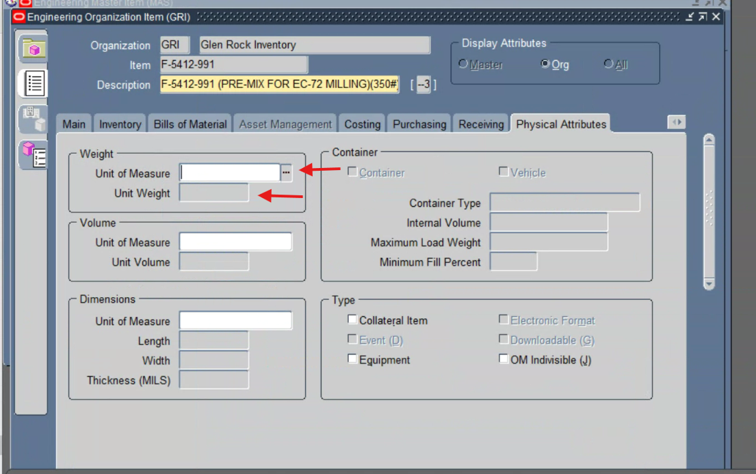
Oracle EBS evidence - Physical Attributes - GRI

F-5412-991
ADHESIVES
Inventory - GRI
Shelf Life Control = Shelf life days PASS
Shelf Life Days = 90 PASS
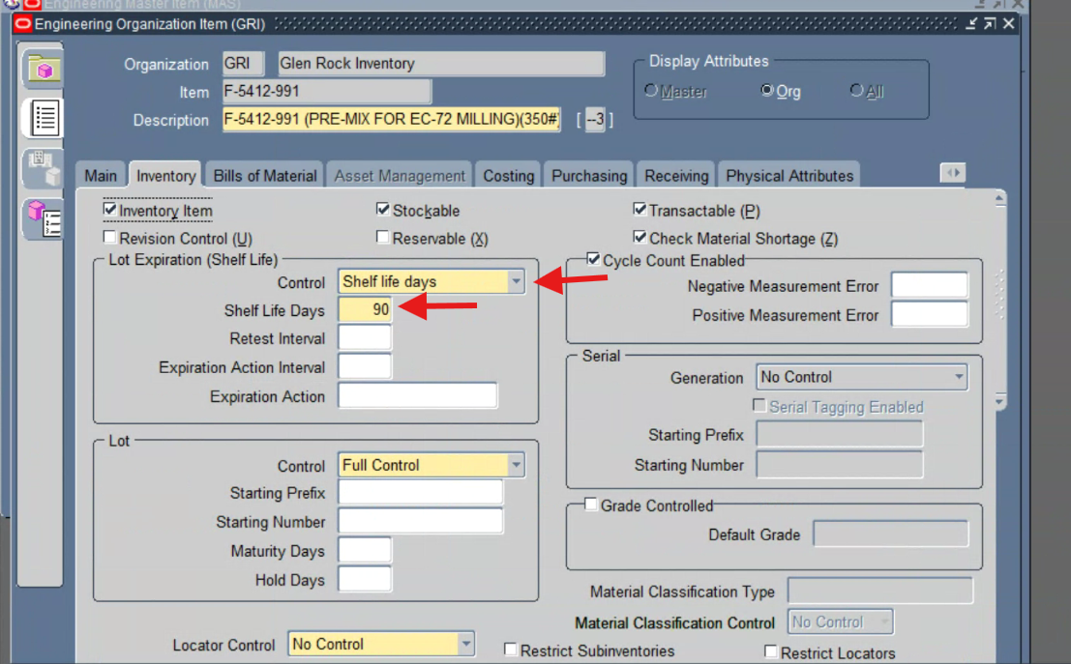
Oracle EBS evidence - Inventory - GRI

F-5412-991
ADHESIVES
Lead Times - GRI
Processing Lead Time = Blank PASS
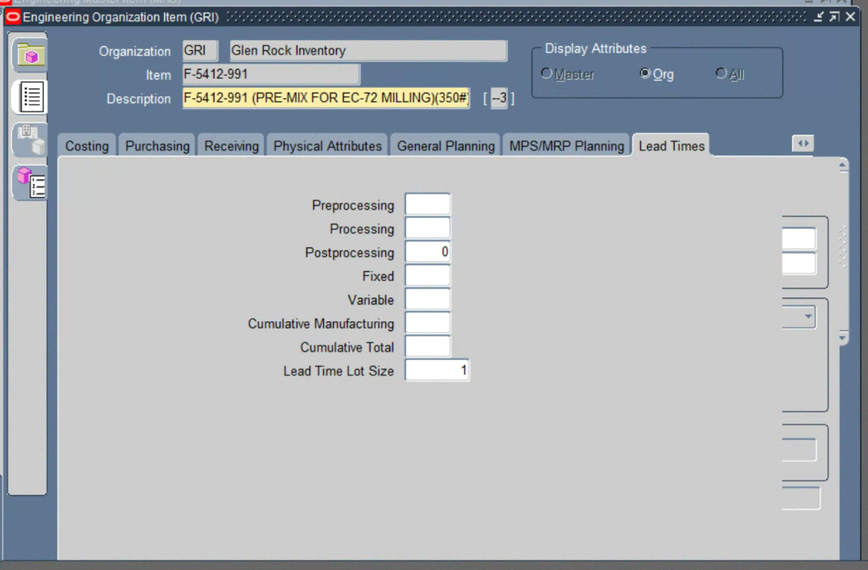
Oracle EBS evidence - Lead Times - GRI

F-5412-991
ADHESIVES
Category Assignments - GRI
Business Unit = ELECTRONICS PASS
Division = ARCARE PASS
Engineering = PDR PASS
INV_CLASS = WIP PASS
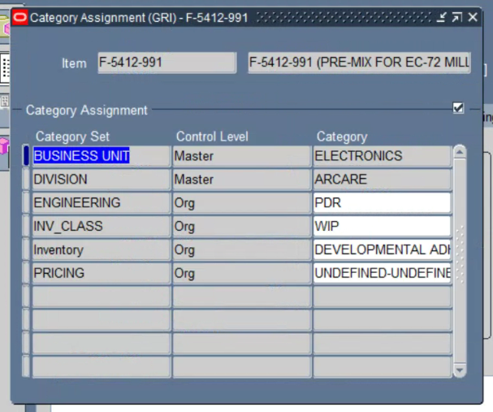
Oracle EBS evidence - Category Assignments - GRI

EL-94916-990
ADHESIVE COATING
Main - MAS Master Inventory
Item Number = EL-94916-990 PASS
Primary UOM = THOUSAND FEET PASS
User Item Type = ARCARE PASS
Long Description = Blank PASS
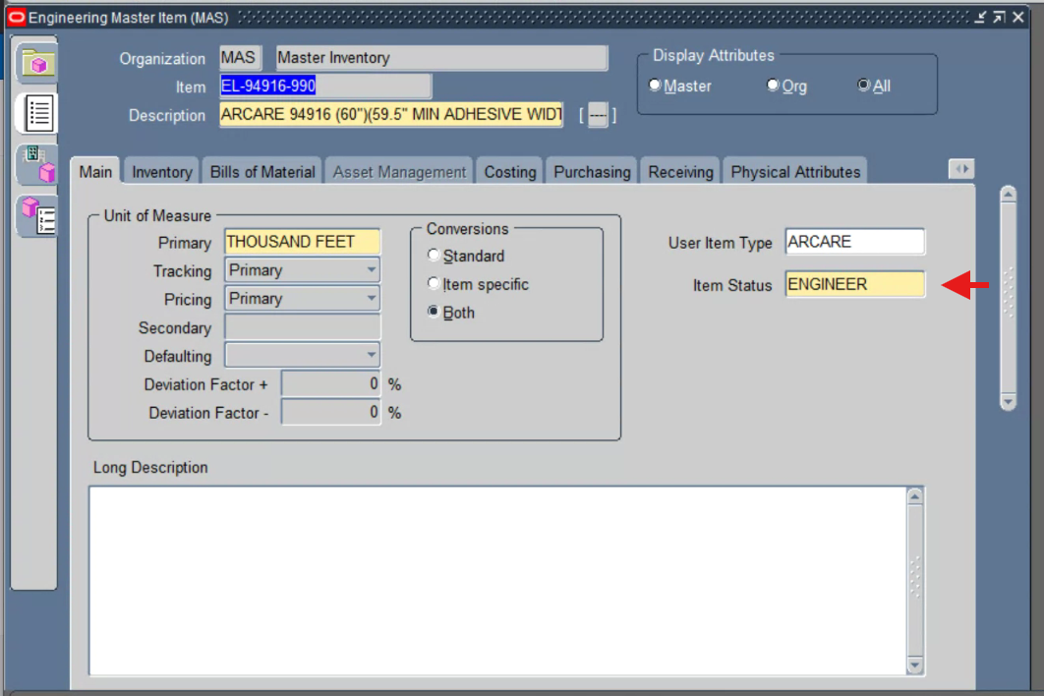
Oracle EBS evidence - Main - MAS Master Inventory

EL-94916-990
ADHESIVE COATING
Main - GRI Glen Rock Inventory
Item Number = EL-94916-990 PASS
Primary UOM = THOUSAND FEET PASS
User Item Type = ARCARE PASS
Item Status = Active PASS
Long Description = Blank PASS
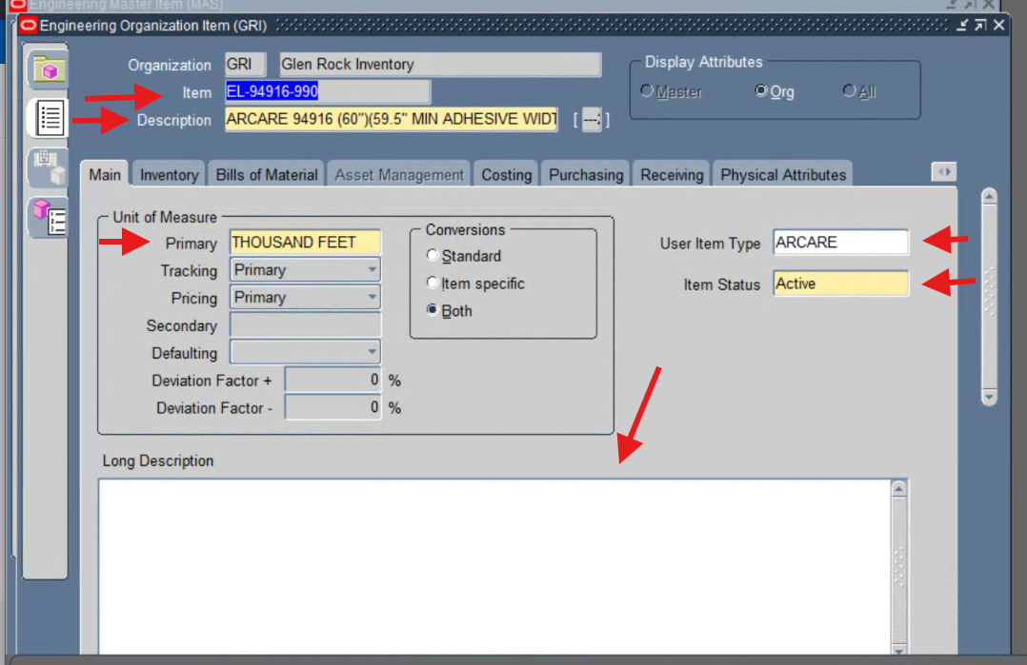
Oracle EBS evidence - Main - GRI Glen Rock Inventory

EL-94916-990
ADHESIVE COATING
Item Descriptive Flexfield - GRI
PDR Number = 26-09 PASS
Initiator = Jilian Thoman PASS
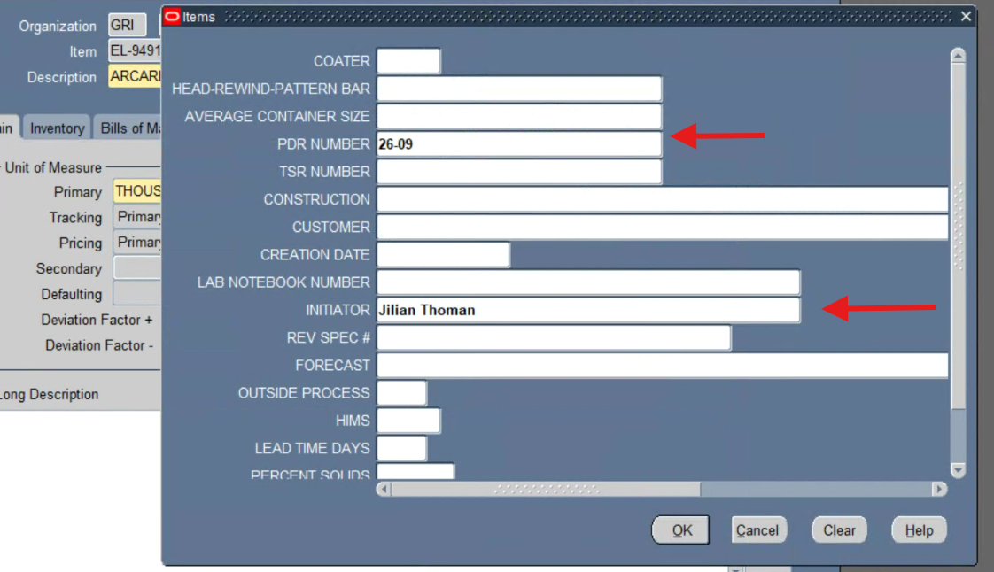
Oracle EBS evidence - Item Descriptive Flexfield - GRI

EL-94916-990
ADHESIVE COATING
Inventory - GRI
Shelf Life Days = 360 PASS
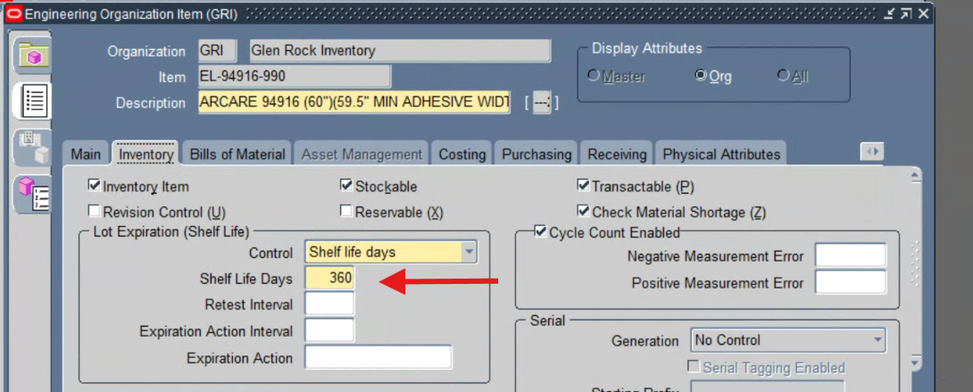
Oracle EBS evidence - Inventory - GRI

EL-94916-990
ADHESIVE COATING
Engineering - GRI
Engineering Item = Yes PASS
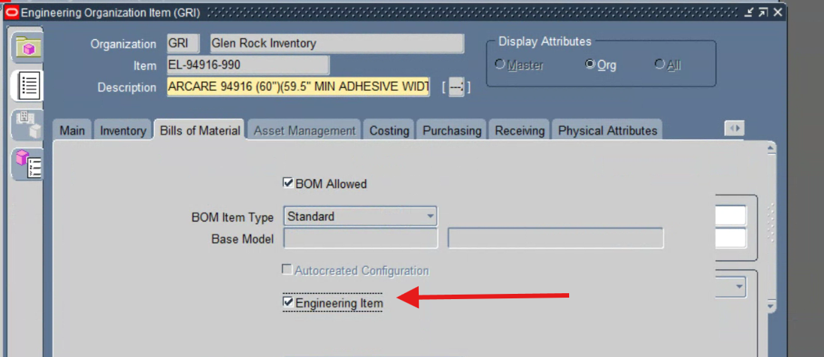
Oracle EBS evidence - Engineering - GRI

EL-94916-990
ADHESIVE COATING
Purchasing - GRI
Outside Processing Item = No PASS
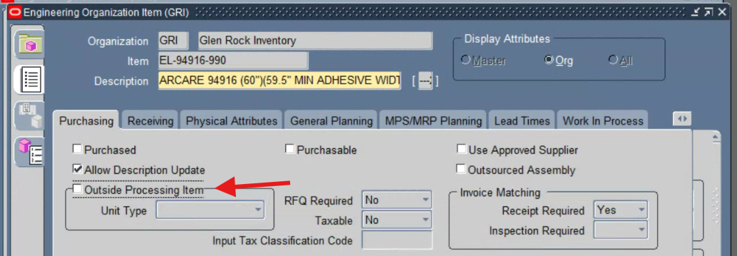
Oracle EBS evidence - Purchasing - GRI

EL-94916-990
ADHESIVE COATING
General Planning - GRI
Planner = 01 PASS
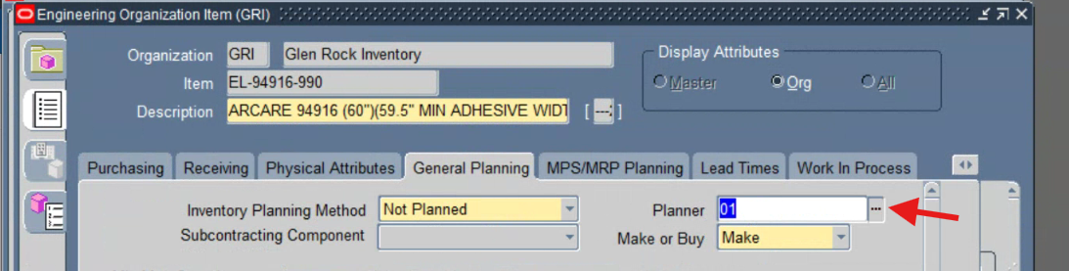
Oracle EBS evidence - General Planning - GRI

EL-94916-990
ADHESIVE COATING
Category Assignments - GRI
Business Unit = ELECTRONICS PASS
Division = ARCARE PASS
Engineering = PDR PASS
INV_CLASS = WIP PASS
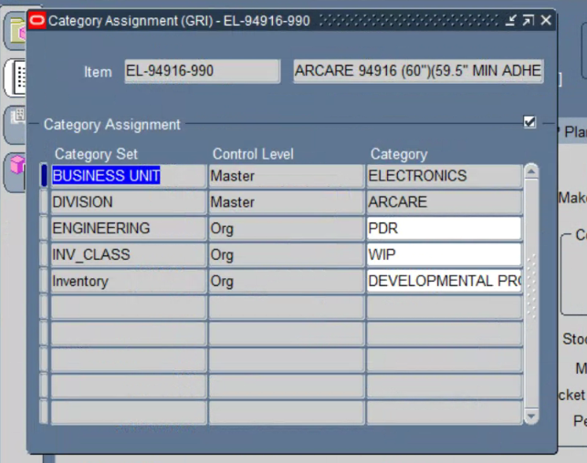
Oracle EBS evidence - Category Assignments - GRI

CV-8345-990
CONVERTING
Main - MAS Master Inventory
Item Number = CV-8345-990 PASS
Description = ARCLAD 8345 (1.50" x 180')(38.1 MM x 55 M) PASS
Primary UOM = ROLL PASS
User Item Type = ARCLAD PASS
Long Description = Blank PASS
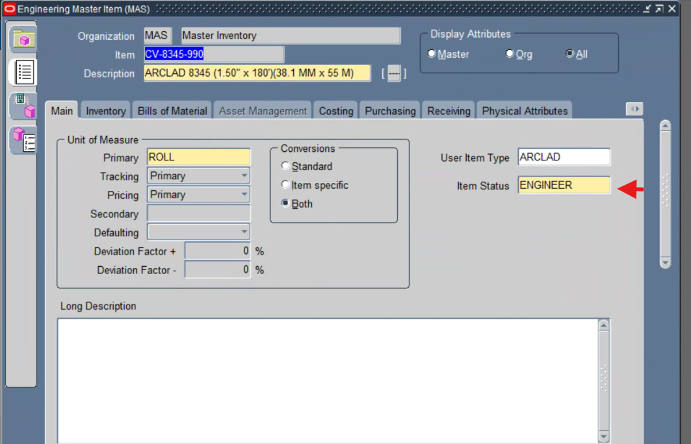
Oracle EBS evidence - Main - MAS Master Inventory

CV-8345-990
CONVERTING
Main - GRI Glen Rock Inventory
Item Number = CV-8345-990 PASS
Description = ARCLAD 8345 (1.50" x 180')(38.1 MM x 55 M) PASS
Primary UOM = ROLL PASS
User Item Type = ARCLAD PASS
Item Status = Active PASS
Long Description = Blank PASS
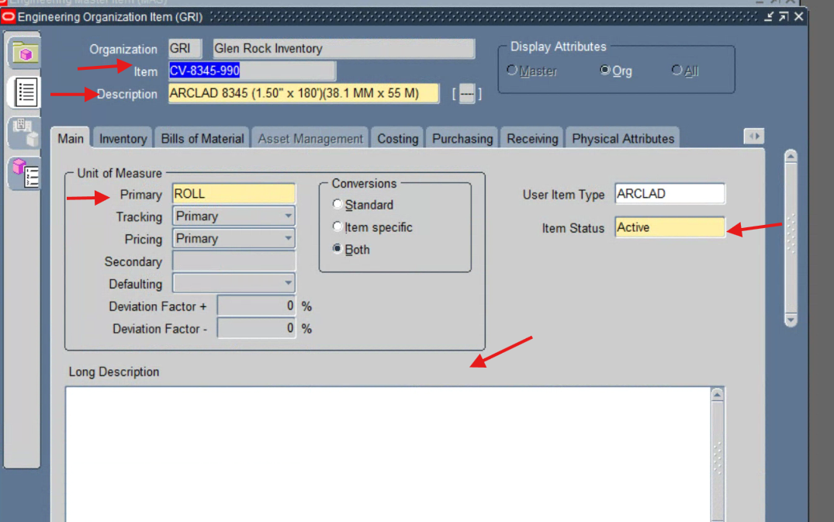
Oracle EBS evidence - Main - GRI Glen Rock Inventory

CV-8345-990
CONVERTING
Item Descriptive Flexfield - GRI
Initiator = Vitaly Falevich PASS
Lead Time Days = 50 PASS
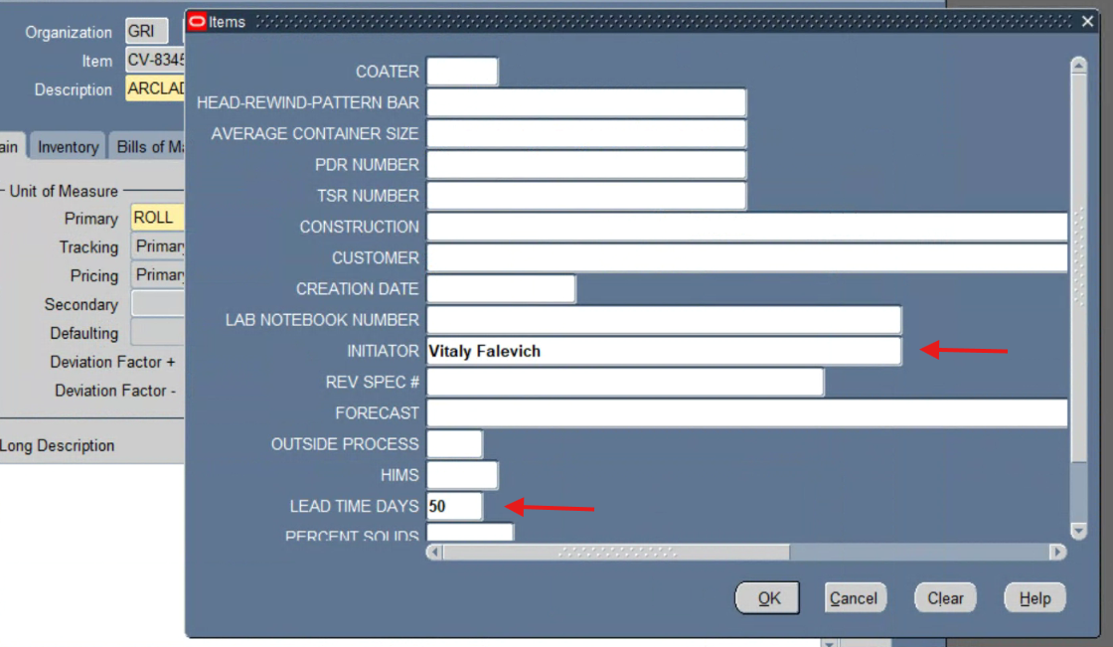
Oracle EBS evidence - Item Descriptive Flexfield - GRI

CV-8345-990
CONVERTING
Order Management - GRI
Shippable = Yes PASS
Customer Ordered = Yes PASS
Customer Orders Enabled = Yes PASS
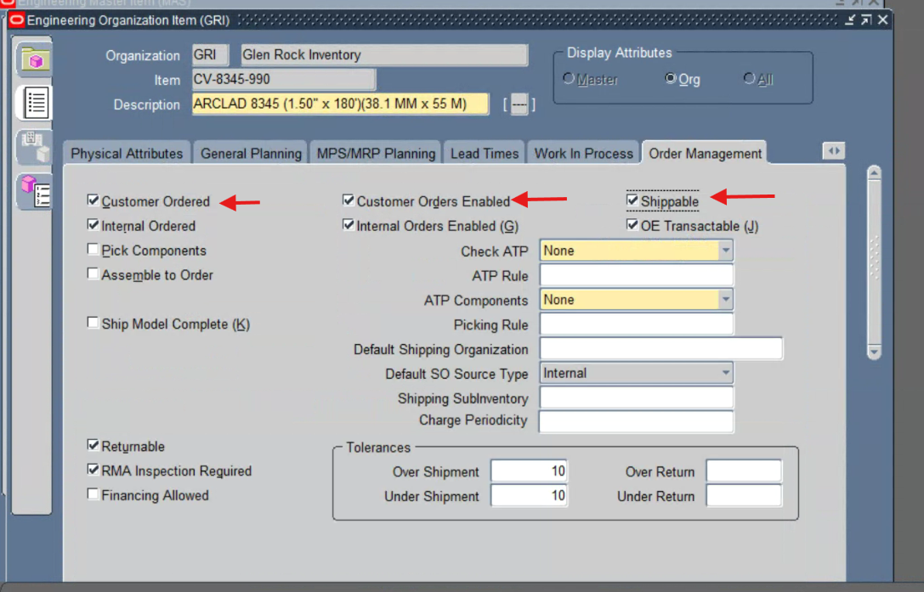
Oracle EBS evidence - Order Management - GRI

CV-8345-990
CONVERTING
Purchasing - GRI
Outside Processing Item = No PASS
Purchasing Item = No PASS
Purchasing Enabled = No PASS
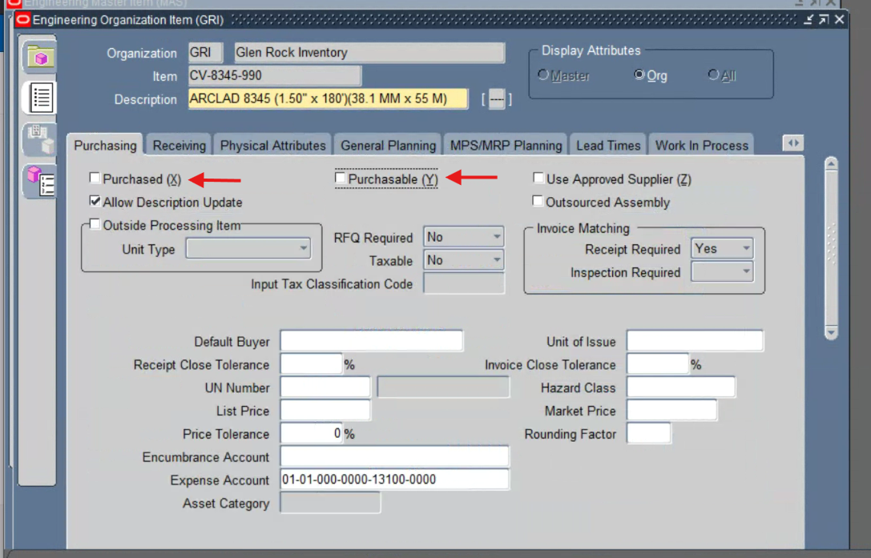
Oracle EBS evidence - Purchasing - GRI

CV-8345-990
CONVERTING
Category Assignments - GRI
Business Unit = CONVERTING PASS
Division = ARCLAD PASS
Engineering = OPS PASS
HTS Code = 3919.10.2055 PASS
INV_CLASS = FG PASS
LOG ROLL / SLIT ROLL = LOG ROLL PASS
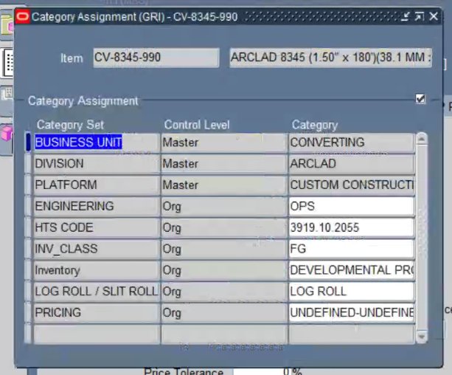
Oracle EBS evidence - Category Assignments - GRI

W-12005-990
LINER COATING
Main - MAS Master Inventory
Item Number = W-12005-990 PASS
Primary UOM = THOUSAND FEET PASS
User Item Type = ARCARE PASS
Item Status = ENGINEER PASS
Long Description = Blank PASS
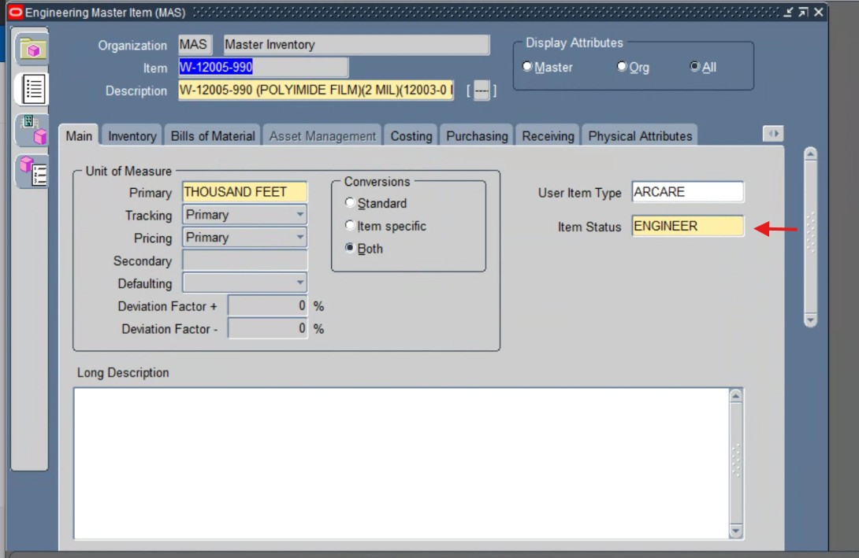
Oracle EBS evidence - Main - MAS Master Inventory

W-12005-990
LINER COATING
Main - GRI Glen Rock Inventory
Item Number = W-12005-990 PASS
Primary UOM = THOUSAND FEET PASS
User Item Type = ARCARE PASS
Long Description = Blank PASS
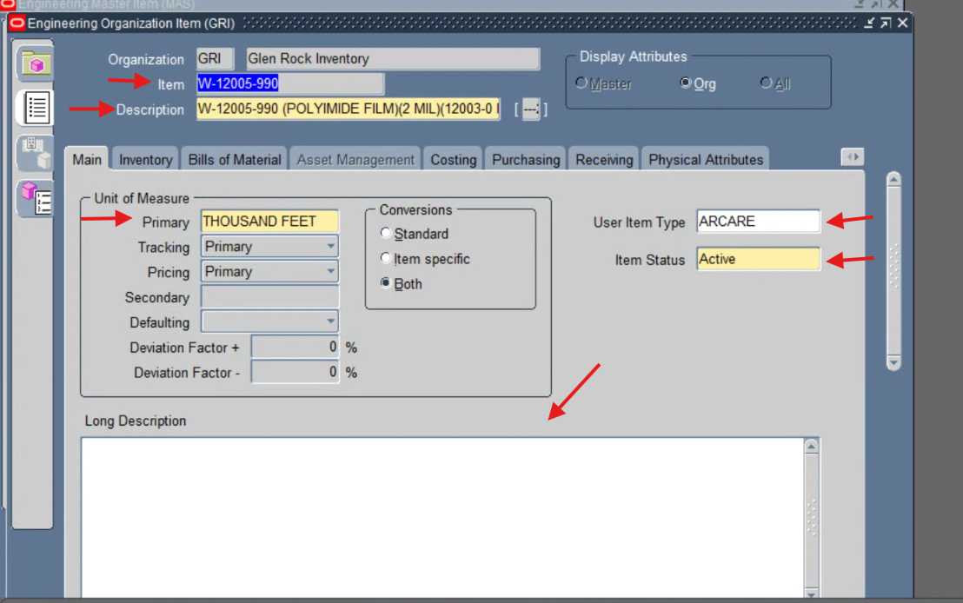
Oracle EBS evidence - Main - GRI Glen Rock Inventory

W-12005-990
LINER COATING
Item Descriptive Flexfield - GRI
PDR Number = 26-10 PASS
Initiator = Christina Wilson PASS
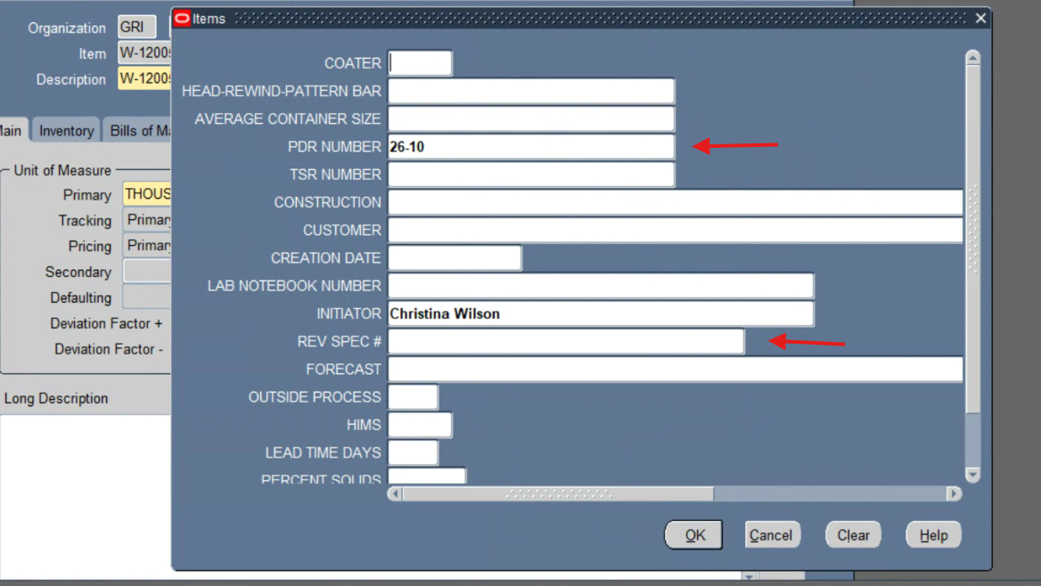
Oracle EBS evidence - Item Descriptive Flexfield - GRI

W-12005-990
LINER COATING
General Planning - GRI
Planner = 01 PASS
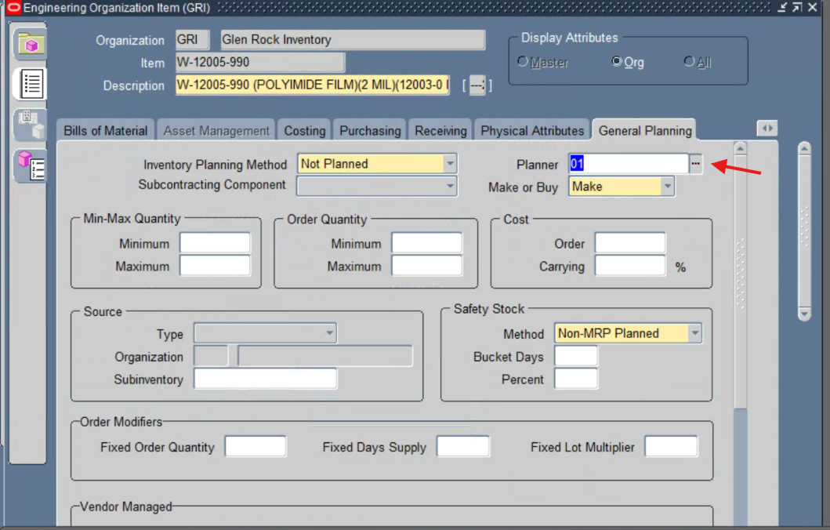
Oracle EBS evidence - General Planning - GRI

W-12005-990
LINER COATING
Engineering - GRI
Engineering Item = Yes PASS
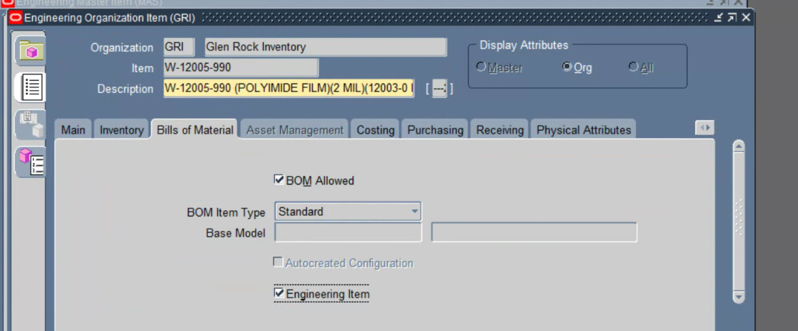
Oracle EBS evidence - Engineering - GRI

W-12005-990
LINER COATING
Category Assignments - GRI
Business Unit = ELECTRONICS PASS
Division = ARCARE PASS
Engineering = PDR PASS
INV_CLASS = WIP PASS
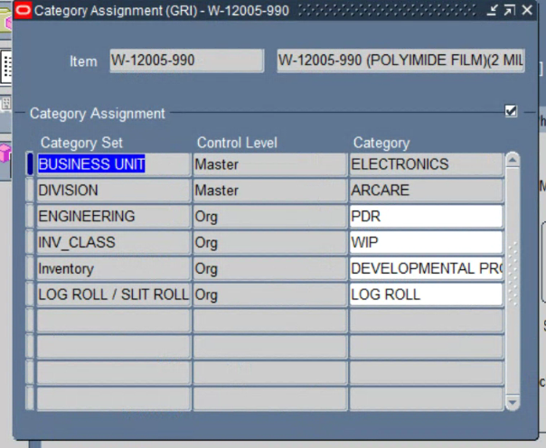
Oracle EBS evidence - Category Assignments - GRI

R-13141-97
RAW MATERIAL ITEM
Main - MAS Master Inventory
Item Number = R-13141-97 PASS
Primary UOM = ROLL PASS
User Item Type = Purchased item PASS
Item Status = ENGINEER PASS
Long Description = Blank PASS
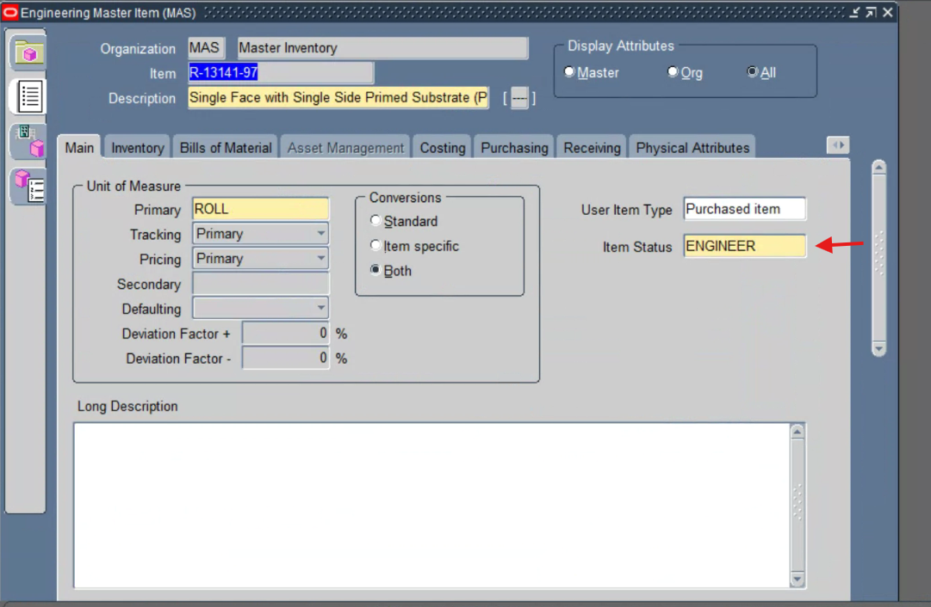
Oracle EBS evidence - Main - MAS Master Inventory

R-13141-97
RAW MATERIAL ITEM
Main - GRI Glen Rock Inventory
Item Number = R-13141-97 PASS
Primary UOM = ROLL PASS
User Item Type = Purchased item PASS
Item Status = ENGINEER PASS
Long Description = Blank PASS
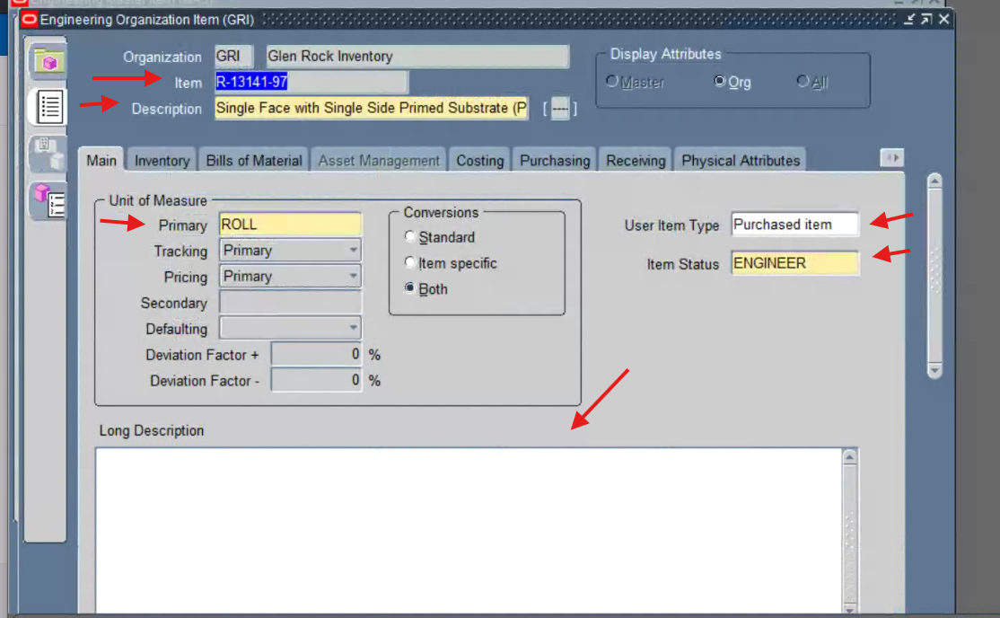
Oracle EBS evidence - Main - GRI Glen Rock Inventory

R-13141-97
RAW MATERIAL ITEM
Item Descriptive Flexfield - GRI
Initiator = Vitaly Falevich PASS
HIMS = 000 PASS
Lead Time Days = 50 PASS
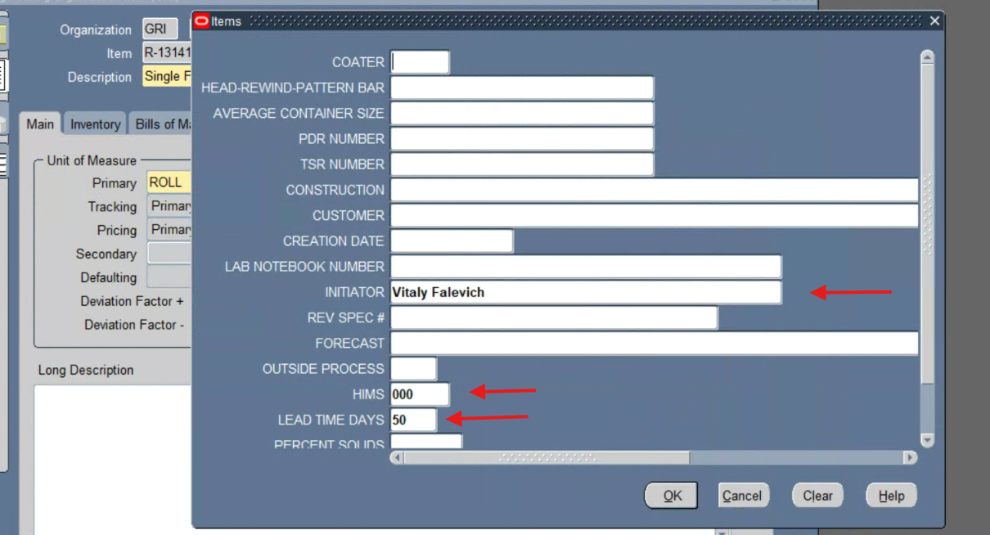
Oracle EBS evidence - Item Descriptive Flexfield - GRI

R-13141-97
RAW MATERIAL ITEM
Inventory - GRI
Shelf Life Control = User-defined PASS
Shelf Life Days = 720 PASS
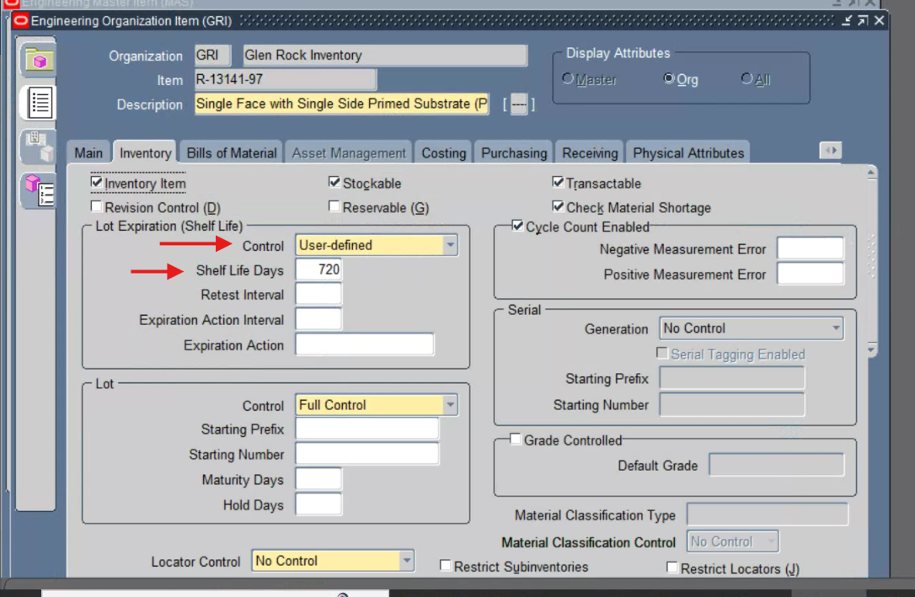
Oracle EBS evidence - Inventory - GRI

R-13141-97
RAW MATERIAL ITEM
Lead Times - GRI
Processing Lead Time = 50 PASS
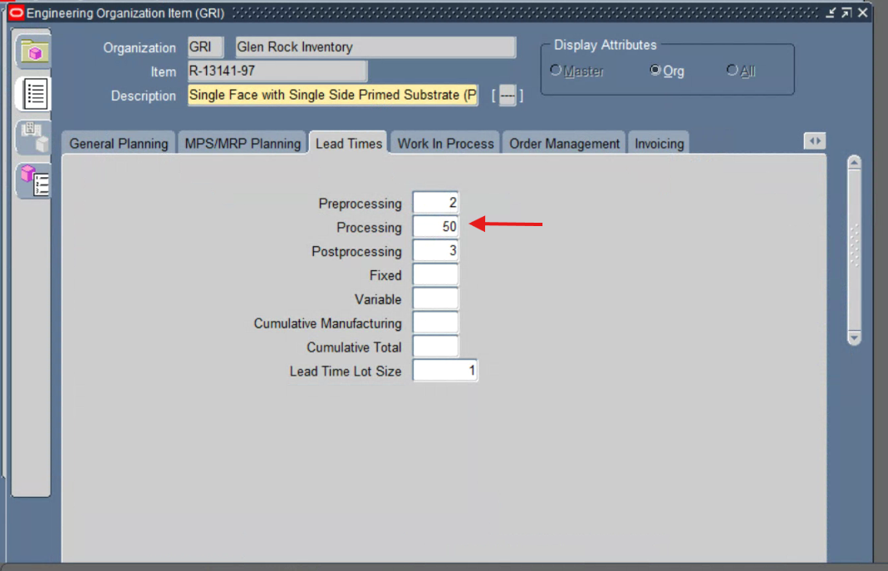
Oracle EBS evidence - Lead Times - GRI

R-13141-97
RAW MATERIAL ITEM
Engineering - GRI
Engineering Item = Yes PASS
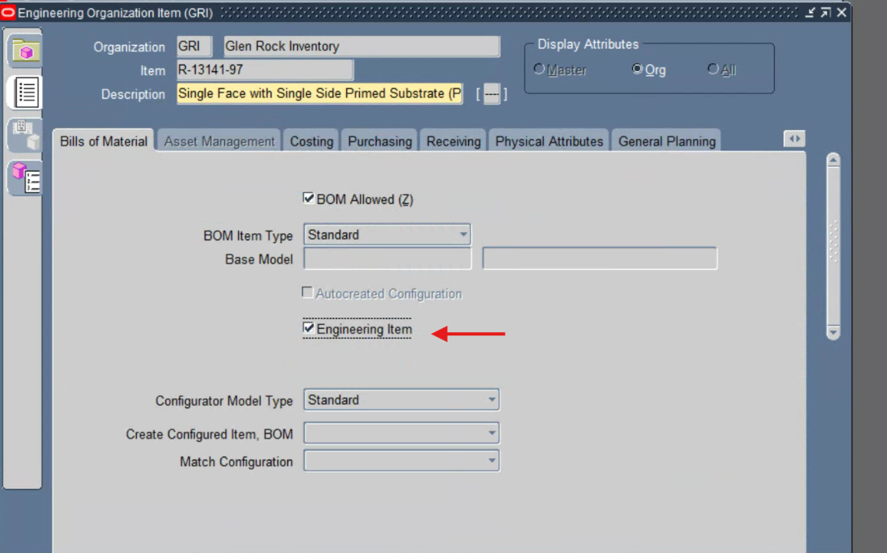
Oracle EBS evidence - Engineering - GRI

R-13141-97
RAW MATERIAL ITEM
Purchasing - GRI
Purchasing Item = Yes PASS
Purchasing Enabled = Yes PASS
List Price = 221 PASS
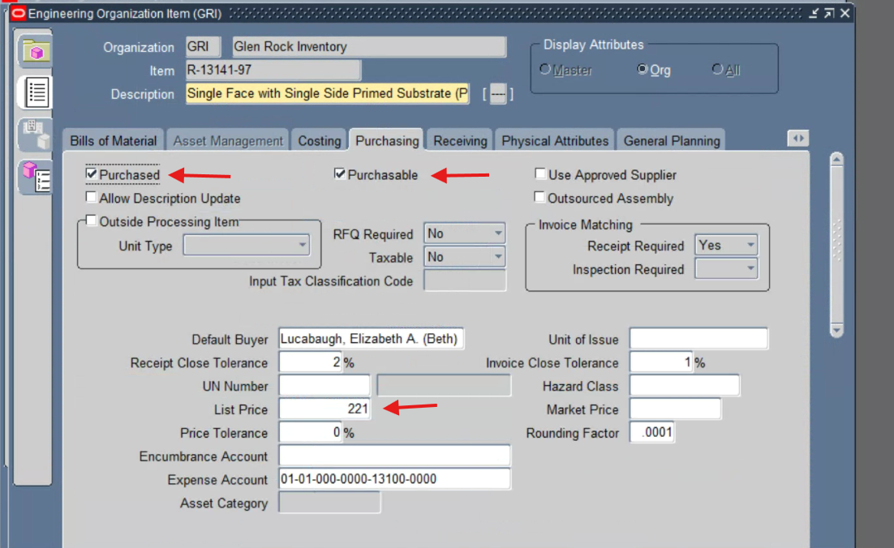
Oracle EBS evidence - Purchasing - GRI

R-13141-97
RAW MATERIAL ITEM
Category Assignments - GRI
Business Unit = MEDICAL PASS
Division = ARCARE PASS
Engineering = OPS PASS
INV_CLASS = RAWS PASS
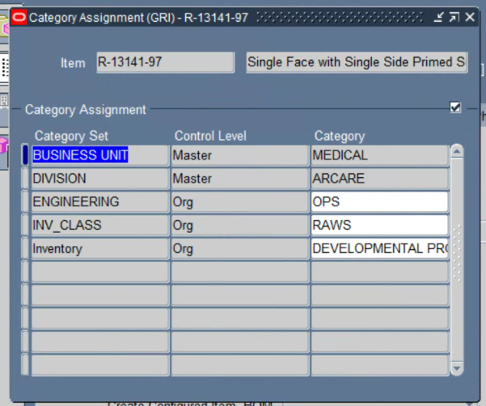
Oracle EBS evidence - Category Assignments - GRI

